**Assert:** If the assert condition is true then the program control will execute the next test step but if the condition is false, the execution will stop and further test step will not be executed.  
whereas,  
**Verify:** There won’t be any halt in the test execution even though the verify condition is true or false. Verify or Soft Asserts will report the errors at the end of the test. Testers need to invoke the **assertAll()** method to view the results. assertAll() shows the exceptions generated by the code.

In TestNG, **Verify** is implemented using **SoftAssert** class.

Soft assert :

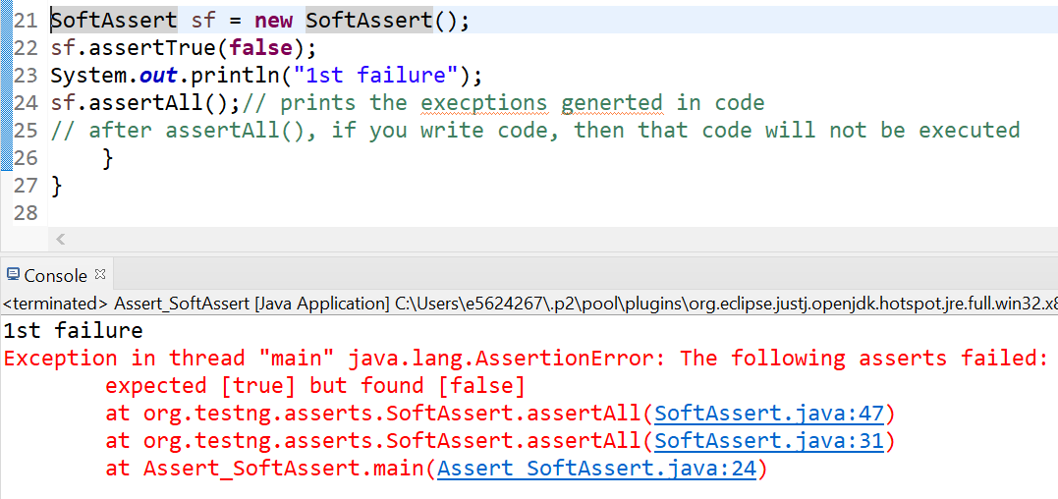

Assert :

Assert.*assertTrue*(Admin.isDisplayed());

WebElement Uname = dr.findElement(By.*id*("txtUsername"));

SoftAssert ss = **new** SoftAssert();

ss.assertTrue(Uname.isDisplayed());

ss.assertTrue(**false**);

System.***out***.println("soft assert continue after fail as well"); // soft assert continue after failure.

// Now we will try assert

Assertion ~~Assert~~ = **new** Assertion(); // HARD ASSERT // nit require to create obj.

~~Assert~~.~~assertTrue~~(Uname.isDisplayed());

~~Assert~~.~~assertTrue~~(**false**);

System.***out***.println("Assert stops execution after assert fails."); // this statement wont get executed

Few Assert method :

Assert.*assertEquals*(**null**, **null**, 0);

Assert.assertFalse(**false**);

Assert.assertNotEquals(**null**, **null**)

Assert.assertNotNull(act)

Assert.assertSame(act, act)

Assert.assertTrue(**false**)

If we want to catch assertion with Try catch then normal catch does not work need below code :

